INSTALLATION & MAINTENANCE MANUAL

FOR

ELECTRO HYDRAULIC DOCK LEVELER

CLIENT : - SRD

PROJECT : - SINNER (NASHIK)

MFG.MONTH & YEAR : - October 2018.

DESIGNED, DEVELOPED & MARKETED,

BY,


NIHVA TECHNOLOGIES PVT. LTD
G-BLOCK, 1ST FLOOR, THERMAX CHOWK
MIDC, ABOVE RENAULT SHOWROOM
CHINCHWAD, PUNE-411019

TEL.NO. - +912066304033
EMAIL: -info@nihva.com
www.nihva.com

A. DESPATCH & UNLOADING:-

1. Loading, for dispatch, will be our responsibility. On receipt of the Dock-leveler at site, please check and ensure that there is no physical damage to the equipment.

2. While unloading the equipment from the transporting vehicle, please ensure to use slings with rated capacity higher than the gross weight of the Stationary lift in packed condition.

3. Slings MUST be hooked ONLY at specified positions. These positions are indicated and marked with a figure of ‘HOOK’. Improper sling position or improper slinging could cause damage to the equipment & serious accidents.

B. ORDERING OF SPARES:-

1. When ordering for spare, please specify the following in your Purchase Order.

- Equipment Name
- Model Number
- Equipment Serial No.
- Part name / Description
- Part Number
- Quantity required
- Delivery period / time
- Mode of dispatch

This would avoid ambiguity and help us serve you better.

DATASHEET FOR DOCK LEVELER:-

CLIENT: - IKEA, CHAKAN PHASE III

- Construction details

1.1 Required Capacity - each : 9 ton
1.2 Model No. : NDL
  - Leveler operation mode : Hydraulically with AC operated.
  - Lip operation mode : hydraulic
  - Operation control : by push buttons and control panel
  - Loading platform height from road
Level : 4 Feet (Will be confirmed during
Detailing)
1.7 Travel above & below dock level : (+) 300 / (-) 200 mm
1.8 Platform Size (L x W) : 2450 x 2200 mm
1.9 Lip size - (L x W) : 2200x 400 mm
1.10 Working length : 2450 mm
1.11 Overall length : 2850 mm
1.12 Maximum slope can be achieved : 8 to 10%
1.13 Clear Pit dimensions (L x W X D) : 2500x 2240x 560 mm
1.14 Hydraulic power pack
1.14.1 Driver type : Direct by electric Motor
1.14.2 Absorbed power : 0.75 kW
1.14.3 Motor Ratings : 0.75/1 kW /HP
1.14.4 Degree of protection for motor : IP 55
1.14.5 Class of Insulation for motor : Class F with temp. Rise limited to
Class B
1.14.6 Motor RPM : 1410
1.14.7 Pump design : 1.6 cc/rev.
1.14.8 Pump pressure : 200 (max) Kg/cm²g
1.14.9 Safety valve set pressure : 90 Kg/cm²g
1.14.11 Pump type : Gear
1.14.12 Valves required : By vendor
1.14.13 Volume of oil receiver : 5 Lit
1.14.15 First fill of oil / Qty : By Vendor
1.14.16 Hydraulic tubing : By Vendor
1.14.17 Instrumentation : By vendor
1.14.18 Control panel : By vendor
1.15 Empty weight : 1040 Kg

DOCK LEVELLER

INTRODUCTION: -

The hydraulic Dock Leveler is the result of many years’ experience in materials handling engineering. “NIHVA” offers the best possible factor of safety with simple, easy to use controls. The high quality of manufacture gives a robust construction and many years of useful life. Each lip and platform movement can be individually controlled (or corrected) by push button.

The dock leveler can be set at any position. During loading, the Dock Leveler is in floating mode i.e. it follows the up/down movements of the vehicle deck. Even with lopsided vehicles, the Dock leveler lip will remain in contact, and toe-traps are avoided by the tilt built into the Dock Leveler.

The whole platform is designed to flex laterally adequately to adapt to sideways tilted vehicles. The leveler always seals perfectly to the lorry bed.

PRINCIPLE: -

Dock Leveler is an adjustable platform used between the transport vehicle and dispatch area of the warehouse of factory for efficient and safe material transfer applications. It bridges the gap between the dispatch area and the transport vehicle and compensates for variations in the truck bed height.

PRE – OPERATING INSTRUCTIONS: -

- Ensure Hydraulic Oil in the power pack.
- Ensure Motor connection and proper earthing.
- Ensure joint leakage.
- Ensure proper location of platform and lip.

ROUTINE MAINTENANCE AND LUBRICATION

These recommendations are applicable to the Dock Leveler considering average daily usage of 15 to 20 times. If it is used more frequently, the same time intervals for the maintenance should be adjusted accordingly.

DAILY: -

- Check Hydraulic pipe lines for leak proof working.
- Check electrical connections for their proper working.

MONTHLY: -

- Grease the hinge pins at bottom frame and top plate joint and extension lip plate hinge joint.

- Grease the main Jack Cylinder and Lip Jack Cylinder, Top and Bottom pins if some frictional sound hears.

- Change Hydraulic Oil (servo 68) viscosity from hydraulic expert & change if required.

ASSEMBLIES & SPARE PARTS LIST:-

- GA DRAWING.

- DECK CYLINDER DETAILS.

- LIP CYLINDER DETAILS.

- HYDRAULIC POWER PACK DETAILS & CIRCUIT.

- ELECTRICAL CIRCUIT.

GA DRAWING:-

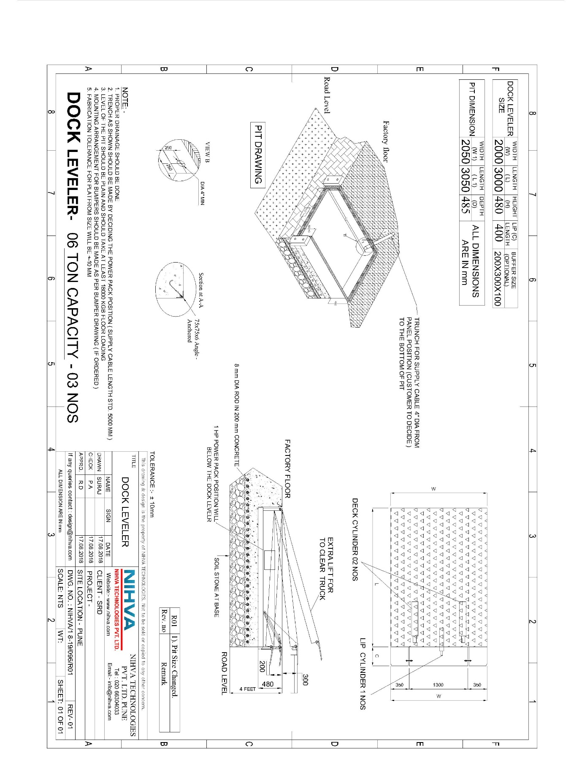

GA DRAWING:-

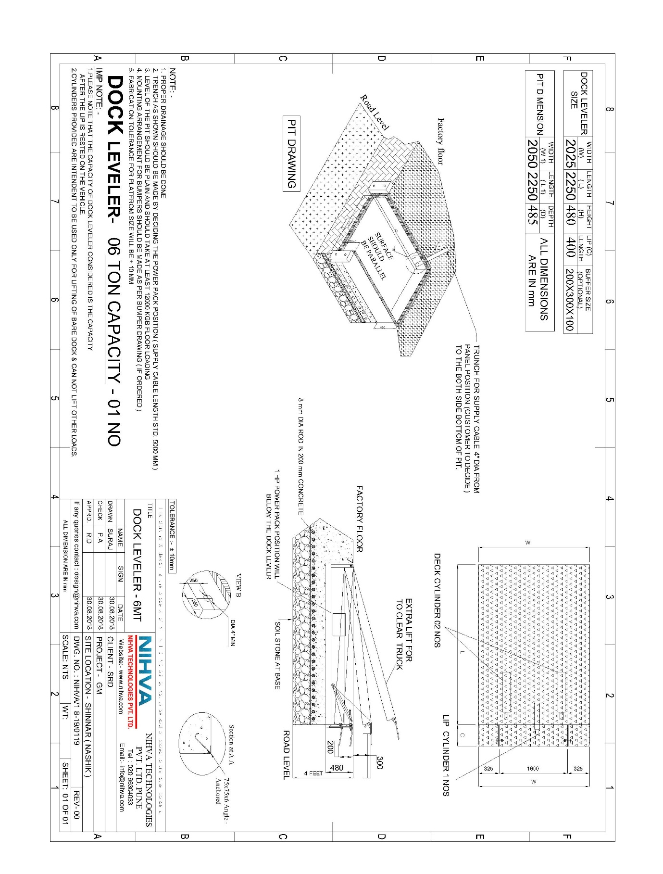

DECK CYLINDER:-

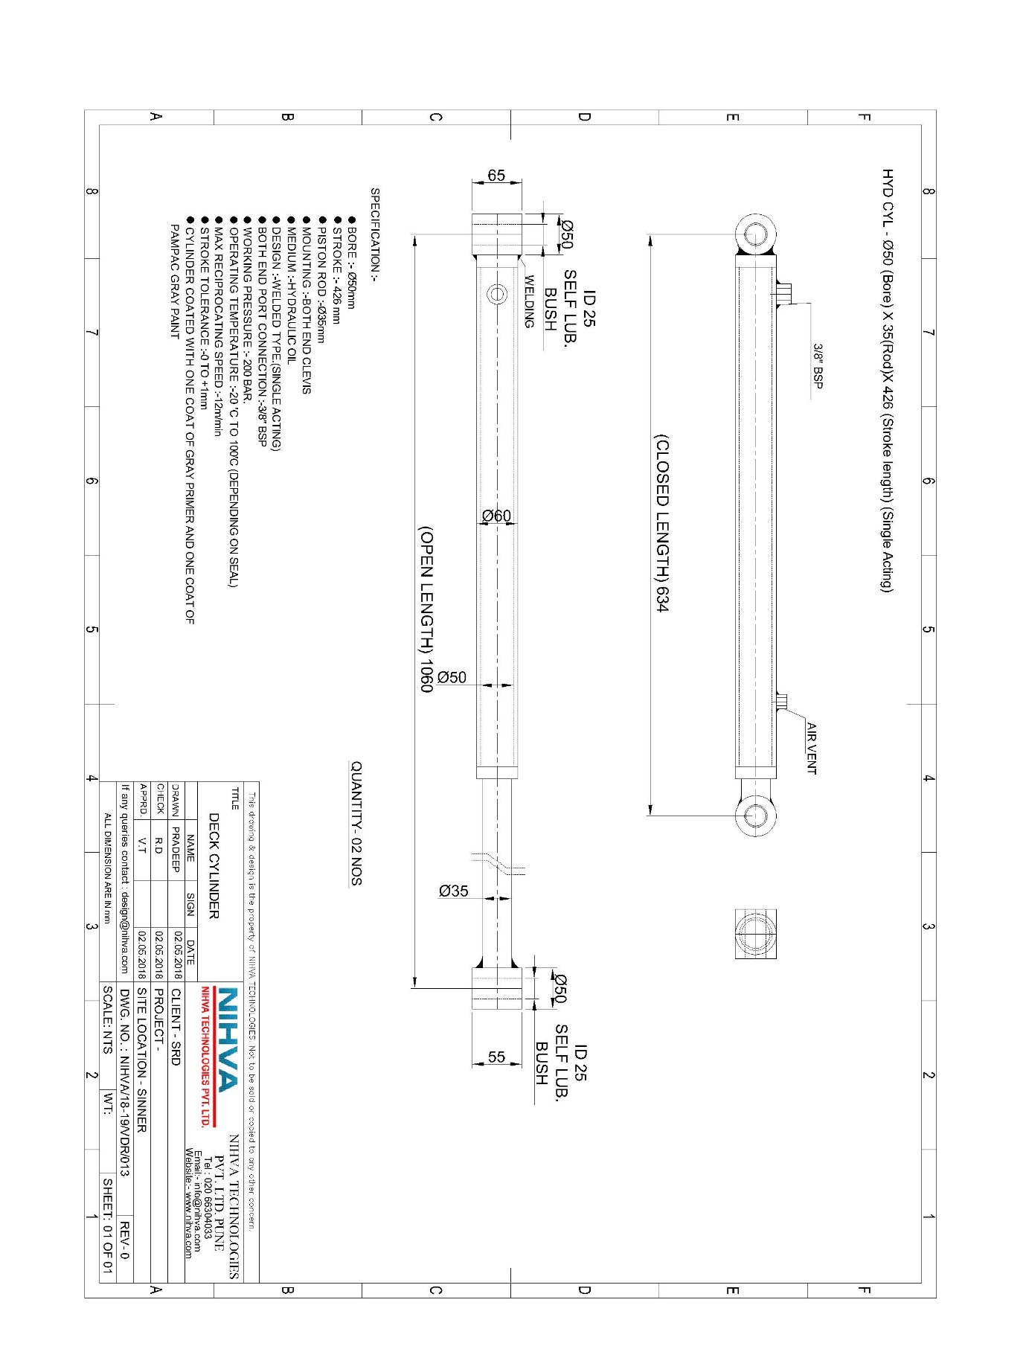

LIP CYLINDER :-

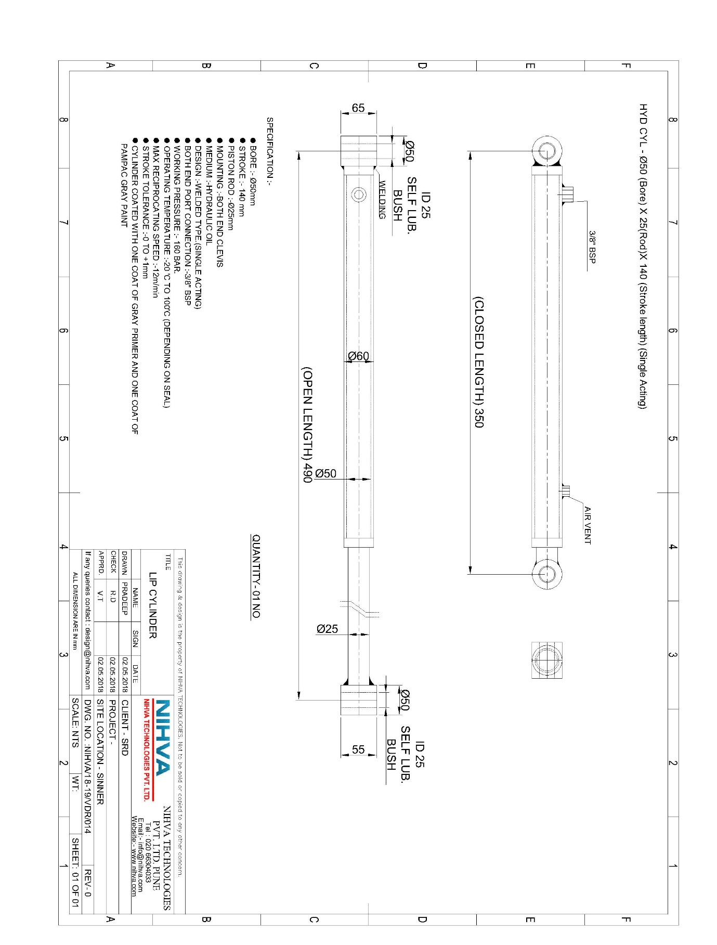

HYDRAULIC POWER PACK DETAILS:–

HYDRAULIC CIRCUIT:-
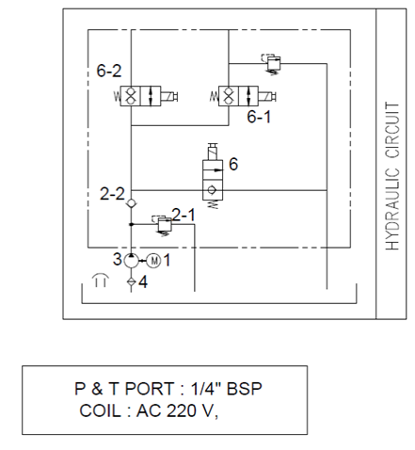

HYDRAULIC CIRCUIT PART LIST:-

SR NO | DESCRIPTION | QTY
1 | MOTOR – 1 HP, 3 PHASE | 01 NO
2 | CHECK VALVE | 01 NO
2.1 | RELIEF VALVE ( RF 1 ) | 01 NO
2.2 | RELIEF VALVE ( RF 2 ) | 01 NO
3 | GEAR PUMP | 01 NO
4 | SUCTION STRAINER | 01 NO
5 | OIL TANK ( 5 LTR ) | 01 NO
6 | SOLENOID COIL ( 220 V ) | 03 NOS

ELECTRIC CIRCUIT & PART LIST:-



